/******************************************************************************
***
* DPS912-Assignment 3
* I declare that this lab is my own work in accordance with Seneca Academic Policy.
* No part of this assignment has been copied manually or electronically from any other source
* (including web sites) or distributed to other students.
*
* Name: Mansoor Ahmad Zafar
* Student ID: 100503226
* Date: Sunday, August 9th, 2026
******************************************************************************
**/
D1) On a scale from 1 to 5, How much did you use generative AI to complete this
assignment?
▪ where:
▪ 1 means you did not use generative AI at all
▪ 2 means you used it very minimally
▪ 3 means you used it moderately
▪ 4 means you used it significantly
▪ 5 means you relied on it almost entirely
▪ Your answer : 2
o D2) On a scale from 1 to 5, How confident are you in your understanding of the
generative AI support you utilized in this assignment, and in your ability to explain it if
questioned?
▪ where:
▪ 1 means "Not confident at all – I do not understand the generative AI support I used
and cannot explain it."
▪ 2 means "Slightly confident – I understand a little, but I have many uncertainties."
▪ 3 means "Moderately confident – I understand the majority of the support, though
some parts are unclear."
▪ 4 means "Very confident – I understand most of the AI support well and can explain
it with minor gaps."
▪ 5 means "Extremely confident – I fully understand the generative AI support I used
and can clearly explain or justify it if asked."
▪ Your answer: 5

Video:
https://youtu.be/dgisOUxvAGU

Questions
1. Generally, what are syslog and rsyslog? Specifically, name three features of syslog/rsyslog and compare them to your embedded debug logging. Will there be any overlap of information?

Syslog is a standard for message logging, it says that there are 3 parts: 1. the software that generates them (the client(s)), 2. the system that stores them (the server) and finally, 3. the software that reports and analyzes them. In practice, it goes from a sender (the client) through some protocol (transport rules) to the receiver (the server).

Rsyslog is an open source software for forwarding log messages for an IP network (protocols that use IP transportation). It implements Syslog and adds on filtering, offline support and configurations.

So, syslog is the standard of a client, server and reporter whereas Rsyslog is a software implementation of it and more. Three features would be, filtering, offline support, timestamped logs. Our embedded logger does support filtering to a lesser degree where they can show both specifically only those levels and lesser whereas ours is just the level and above (debug shows debug level and above or warning shows warning and warning+ but not just warning). They include offline support if the server was offline, but ours doesn't and finally, timestamped logs are ones we both have.

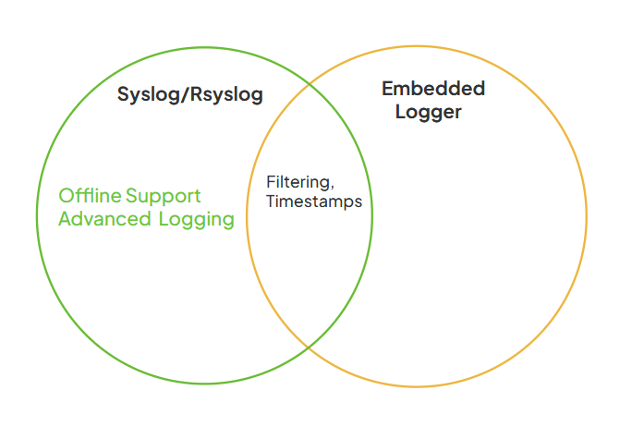

2. Name five features of syslog-ng.

1. format log messages using Unix Shell like variable expansion
2. send log messages to local applications
3. Logging directly into a database
4. Classify incoming log messages and at the same time extract structured from unstructured syslog messages
5. correlate multiple incoming messages to form a more complex correlated event

3. Name five ways syslog-ng is an improvement over syslog/rsyslog.

1. Auto correlation of multiple incoming messages to one correlated message
2. can log directly into a database
3. can directly extract unstructured data
4. can define reusable components
5. modern syntax ruling system

4. Consider a Log Server that has to manage embedded logs for a massive amount of processes on a massive amount of machines. Name three ways the server could manage the connections to each process

1. threads per connection
2. multiplexing via select()
3. event driven I/O epoll()

5. Consider a Log Server that has to manage embedded logs for a massive amount of processes on a massive amount of machines. With such a large amount of data in the logs, name three ways a user could extract useful information from them (be general).

1. Filter by log type, generally focus on INFO or ERROR logs.
2. Search for certain keywords, within the logs, grep or search for specific key words
3. aggregate the logs to one centralized system for ease of manageability.

6. Explain how gdb could be used on a Linux machine to attach to a process and get thread information. Is this also useful in debugging?

By getting the PID then attaching it via -p, you can attach gdb onto a process. It works by basically using ptrace. Ptrace has it so the tracer can inspect the tracee (another process). Which simply lets the tracer use the kernel as a middleman to inspect and edit things from the tracee.

This is useful for debugging as getting things like thread or process information can tell you about deadlocks, states of variables, and watch the entire control flow step by step ... All of these help debugging as you would be able to see and go through what's going on through your program.

Screenshots:
